
COIT20265-Networks and Information Security Project
Term 1, 2026
Assignment 1 –Project Proposal

Prepared by:
Suhartanto Tanuwijaya (12290667)
Dev Anand Suresh(12272597)
Sai Teja Akula

Campus: Sydney
Tutor: Biplob Ray
Table of Contents
Overview 3
Project Background and Justification 3
Problem Statement 3
Project Objective 3
Project Scope 3
Implement Management Overview 3
Tasks 4
Roles 5
Roles 5
Responsibilities 5
Resources Requirements 6
In-kind 6
Cash 6
Personnel 7
Project Risk and Mitigation 7
Schedule 7
Ethical and Professional Issue 7

Overview

Project Background and Justification
The rapid proliferation of Internet of Things (IoT) devices has transformed modern networks, creating highly interconnected environments across smart homes, healthcare, and industrial systems.
However, the resource-constrained nature of these devices and the massive volume of generated traffic have expanded the attack surface, introducing severe security vulnerabilities. Traditional signature-based Network Intrusion Detection Systems (NIDS) struggle to identify zero-day exploits and often fail to scale effectively in dynamic, heterogeneous IoT ecosystems.

Problem Statement
Based on conducted study by Abdallah et al (2022) , found there are couple of problem by implementing network intrusion detection system, which are as follow :
- High false alerts or alarm rate and high rate of malicious attacks are undetected
- Incoming New attacks need to be more attention by developing machine learning models for easier detection attacks.

Project Objective
A study has been conducted by Abdallah et al (2022) , objectives implement network intrusion detection are as follow :
- Monitoring host and network
- Analyzing behaviour of computer networks
- Generate alerts
- Respond to suspicious behaviours
Also based on meeting result with client , we has concluded our project objectives would be focus on machine learning able to send alerts , either normal or malicious network with 70% accuracy detection in industrial sector.

Project Scope
The project will be aimed based on client needs and wants by build an application with supported supervised machine learning model who able to network intrusions detections , which is either normal or malicious traffics. Also, data collection methodology would be quantitative method and use secondary data’s , such as UNSW-NB15 and NSL-KDD . The UNSW-NB15 contain 100 GB raw network packets , captured by using TCP dump, save into pcap file , classified into several type of attacks based on conducted study by by Moustafa et al (2015) . Next, NSL-KDD dataset has been capture by McHungh (2000) and been classified into 2 type , which are normal and abnormal traffics.
Secondly, the application would be built by using Node-red with several combination language such as Python and Json, including implementation of testing processes to achieved high level of accuracy. Moreover, managerial aspect and project schedules also would be discussed as well in this project However, the project has not includes costs and benefits.

Implement Management Overview
Key points need to be explain:
- How you will approaches for this project :
SDLC : System Development Life Cycle



- WBS
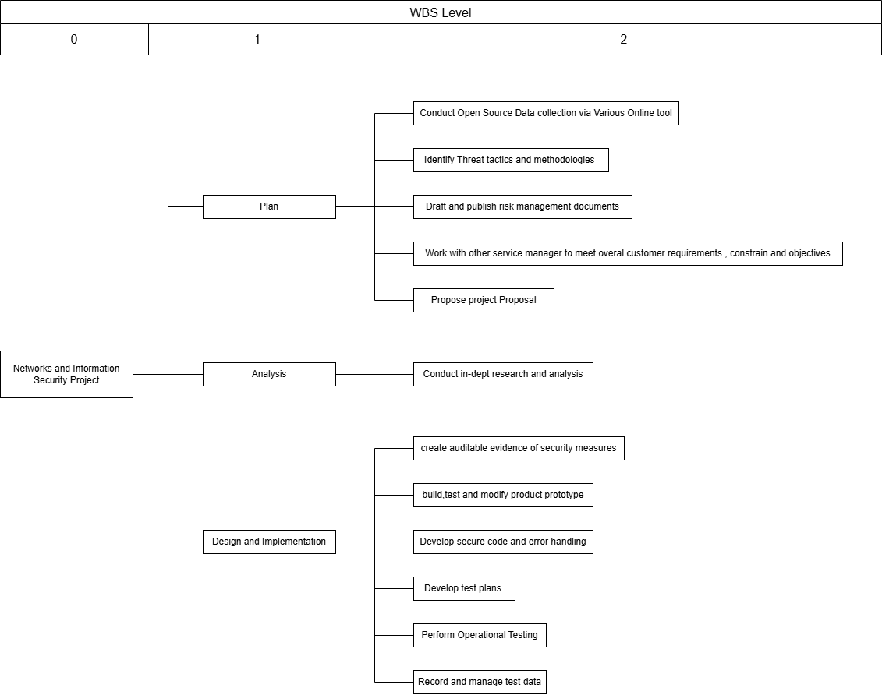

Tasks
- List the detail tasks you plan to do in your project
Task | Description | Deliverables
Work with other service managers to meet overall customer requirements, constraint and objectives | Identifies client requirements,constraint and objectives | - Identified objectives,needs and constraint
Identify threat tactics and methodologies | Identified data collection methods and dataset would be use . | - Data collection methods : Quantitative and secondary data sources
Conduct Open Source data collection via various online tools | Collecting network traffic dataset from credible sources and online | - Scatterplot Visual  - Table of attribute dataframe  - Table of evaluated attributes
Conduct in-dept research and analysis | Research and analysis indicators for malicious and normal network traffic | - Normal and malicious indicators
Draft and publish risk management documents | Provide and identifies project risks and mitigation plans | - Identified management risks and mitigation plans
Build , test and modify product prototypes using working models or theoretical models | Developed a python-based machine learning model and tested some test cases | - Prototype Machine Learning  - Test cases result  - Training
Programming | Write source code machine learning by using python language | - Source code Machine learning Model
Record and manage test data | Prepare a dataset to be tested and documentation the test cases result | - Documentation  - Pilot , pre test and primary test dataset
Perform Operational Testing | A user who are testing prototype and developed machine learning model based on test cases instructions | - Test cases findings
Develop test plans to address specifications and requirements | Prepare scenarios testing to user or actor who are preform testing. | - Developed test cases
Create Auditable evidence of security measures | Prepare key indicator measurement of detection attacks | - Developed key indicators of detection
Provide Recommendation for possible improvement and upgrades | Provide next steps recommendation report to client or higher position executives | - Final report documentation  - Presentation
Review audits of projects | Provide performance evaluation team contribution | - Contribution reports

Roles
Student Name | Role | Justification
Suhartanto Tanuwijaya and Dev Anand | All-Source Analyst | There are some skills, knowledges and abilities are needed for this role , as follow :  Knowledge :  - Understand network traffic analysis method  - Understand cyber threats and vulnerabilities  - Understand physical and logical network devices  - Understand to extract,analyze and use metadata  - Understand internet applications works and OSI model protocols  Abilities :  - Has critical thinking  - Ability to evaluate, analyse and synthesize large quantities of data into high quality products  Skills :  - Able to evaluate information for reliability ,validity and relevance  - Able to using multiple analytic tools such as WEKA.
Suhartanto , Dev Anand Suresh | Information System Security Developer | There are some skills, knowledges and abilities are needed for this role , as follow :  Knowledge :  - Understand computer algorithm  - Understand cyber threats and vulnerabilities  - Understand database system  - Understand operating systems  - Understand network protocols  Abilities :  - Has critical thinking  Skills :  - Able to discerning protection needs of network
Suhartanto , Dev Anand Suresh | Software Developer | There are some skills, knowledges and abilities are needed for this role , as follow :  Knowledge :  - Understand computer programming principles  Abilities :  - Handle complex mathematical concepts  Skills :  - Able to using code analysis tools
Suhartanto Tanuwijaya and Dev Anand | Threat / Warning Analyst | There are some skills, knowledges and abilities are needed for this role , as follow :  Knowledge :  - Understand attack methods and techniques  Abilities :  - Could think as threat actors  - Has critical thinking  Skills :  - Able to using multiple analytic tools such as WEKA.
Dev Anand and Sai Teja | System Testing and Evaluation Specialist | There are some skills, knowledges and abilities are needed for this role , as follow :  Knowledge :  - Understand system testing and evaluation method  Abilities :  - Conducting test events  - Write test plans  Skills :  - Able to collect ,verify and validate test data
Sai Teja and Dev Anand | IT Project Manager | There are some skills, knowledges and abilities are needed for this role , as follow :  Knowledge :  - Understand of risk management processes , standards and practices , including methods and mitigation risks.  - Understand resource management principles and techniques  - Understand organization objectives  Abilities :  - Perform risks management standards  Skills :  - Able to identify actions needed to improve relative to project goals or objectives
Suhartanto | Cyber Operator | There are some skills, knowledges and abilities are needed , as follow :  Knowledge :  - Understand collection management processes, capabilities and limitations  Abilities :  - perform network collection tactics , techniques and procedures  Skills :  - Able to survey, collection and analysis of wireless LAN data  - Able to use various open source data collection tools

Responsibilities
Task | Technical Lead | Reviewer
Identify threat tactics and methodologies (T708) | Suhartanto | Dev Anand
Conduct Open Source data collection via various online tools | Suhartanto | Dev Anand
Draft and publish risk management documents | Sai Teja | Dev Anand
Conduct in-dept research and analysis | Dev Anand | Suhartanto
Build , test and modify product prototypes using working models or theoretical models | Suhartanto | Dev Anand
Develop secure code and error handling | Dev Anand | Suhartanto
Record and manage test data | Sai Teja | Dev Anand
Perform Operational Testing | Sai Teja | Dev Anand
Develop test plans to address specifications and requirements | Dev Anand | Sai Teja
Create Auditable evidence of security measures | Dev Anand | Suhartanto
Provide Recommendation for possible improvement and upgrades | Sai Teja | Dev Anand
Review audits of projects | Sai Teja | Dev Anand

Resources Requirements

In-kind
Resource | Justification | Cost/License
Wireshark | Packet has been captured would be used in data collection task to categorize the attributes and classify classes | Free, GNU GPL Open Source
Microsoft Project | Scheduling project timeline and milestones need to be achieved including resources. | Free,
Weka | Its needed to identifies threat and warning key indicators | Free
Node-Red | Needed to be able create Python Based IoT Web Smart Application | Free

Cash
Resource | Justification | Cost
Google Colab Pro | Data has been captured , would be evaluate by using Google Colab Pro and training as well for create a new machine learning model  Google Colab Pro would provide better compute specification , which is it could able to machine training and evaluate data faster than free plan | $ 75.62 per month

Personnel
Resources | Justification | Cost
All-Source Analyst
Information System Security Developer
Software Developer
Threat / Warning Analyst
System Testing and Evaluation Specialist
IT Project Manager
Cyber Operator

Project Risk and Mitigation
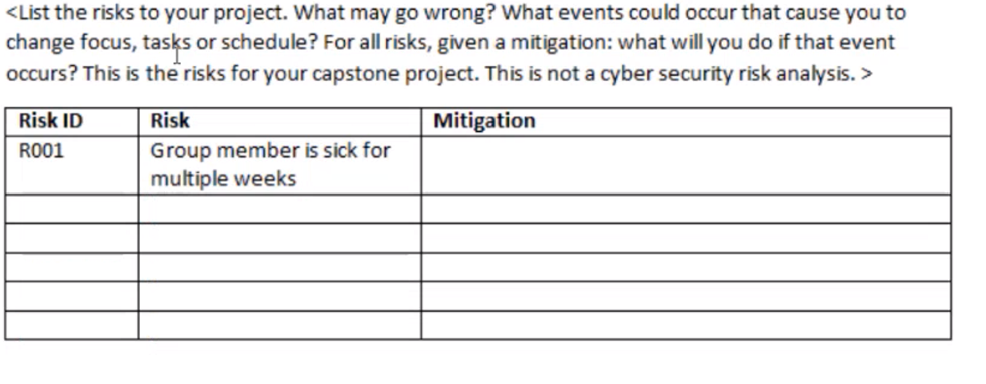
Risk ID | Risk | Mitigation
R001 | Group Member Sick during Training or collecting data | Find a secondary dataframe from credible sources, such as UNSW , McKinsey and other data firm
R002 | Google Collab having downtime | Find other platform who are able to perfom machine learning such as Juypyter Notebook

Schedule
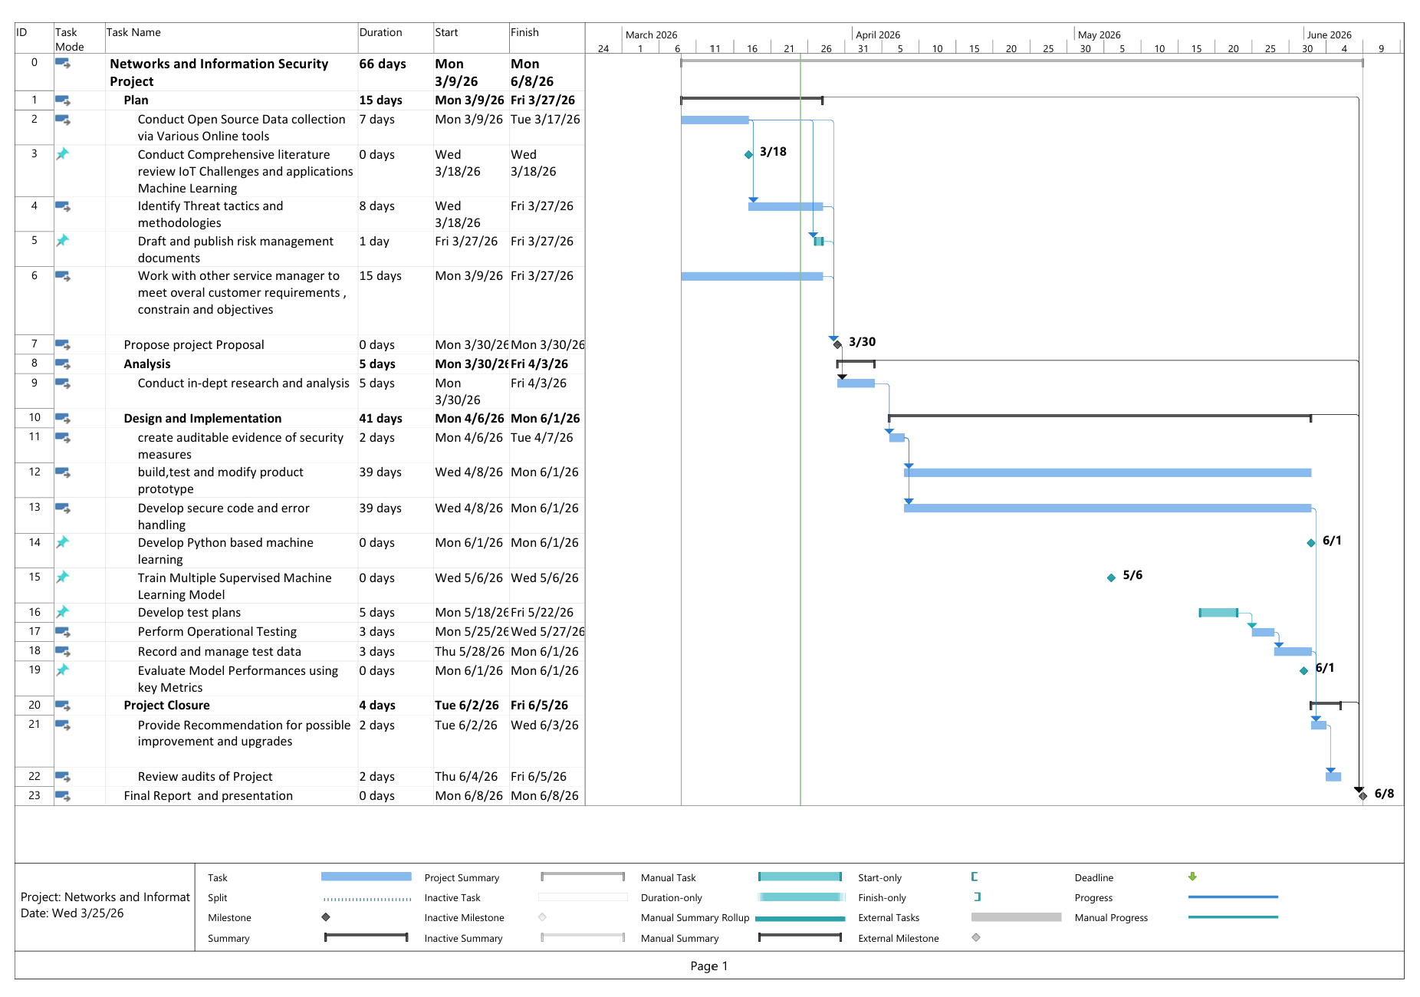

Ethical and Professional Issue

References
Abdallah, E. E., Eleisah, W. & Otoom, A. F., 2022. Intrusion Detection Systems using Supervised Machine Learning Techniques: A survey. Procedia Computer Science, Volume 201, pp. 205-212.
Almasir, Y. et al., 2025. Ransomware Detection on IoT Edge Using Optimized Deep Representation Learning. TechRxiv.
McHungh, J., 2000. Testing intrusion detection systems: a critique of the 1998 and 1999 darpa intrusion detection system evaluations as performed by lincoln laboratory. ACM Transactions on Information and System Security, Volume 3, pp. 262-294.

